38.201
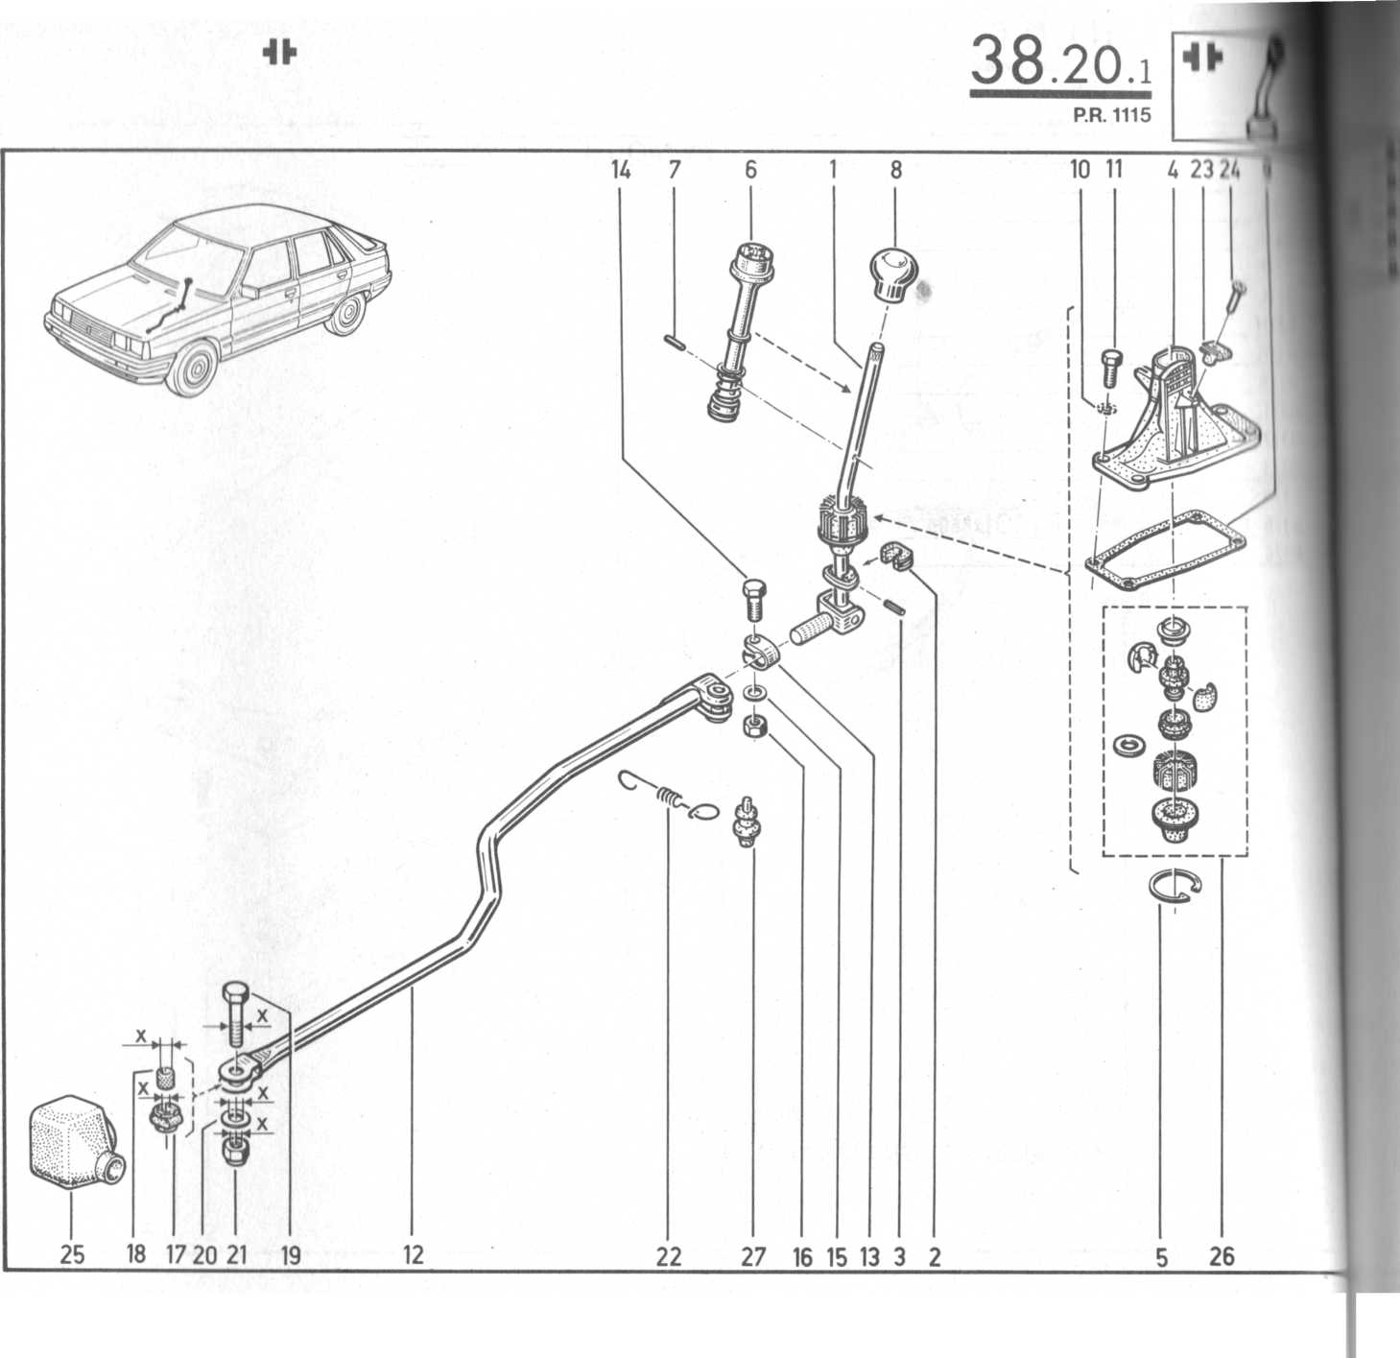
1 | // | (M) | 697 | 092 | t (a)
 | // | (II) | 17 J | 461 | t (b)
 | // | 1)1 | 464 | 163
2 | // | 1)0 | 701 | 955
3 | // | 03 | 067 | 069 | t
 | // | 00 | 739 | 933
4 | 77 | 00 | 694 | 733
b | 77 | 03 | 066 | 038
6 | 77 | 01 | 464 | 164
7 | 77 | 03 | 067 | 071
8 | 77 | 04 | 001 | 309 | + ITLT
 | 77 | 00 | 767 | 475 | mr
 | 77 | 04 | 001 | 310 | t nu
 | 77 | 04 | 003 | 730 | t nu
 | 77 | 04 | 003 | 731 | nu
9 | 77 | 00 | 698 | 329
10 | 79 | 03 | 056 | 008
11 | 77 | 03 | 001 | 123
12 | 77 | 00 | 697 | 093 | t (a)
 | 77 | 00 | 722 | 941 | t(c)
 | 77 | 00 | 726 | 501 | t (d)
 | 77 | 00 | 728 | 749 | t (e)
 | 77 | 00 | 731 | 837 | t ( B37F)
 | 77 | 00 | 732 | 873
13 | 77 | 00 | 579 | 550
14 | 77 | 03 | 001 | 240
15 | 79 | 03 | 053 | 043
16 | 79 | 03 | 032 | 018
17 | 77 | 00 | 701 | 488 | t (X = 9)
 | 77 | 00 | 722 | 942 | t (X = 12)
 | 77 | 00 | 743 | 133 | (X=12)
18 | 77 | 05 | 010 | 043 | t (a)
 | 77 | 05 | 010 | 081 | (X = 6)
 | 77 | 05 | 010 | 093 | (X = 8)
19 | 77 | 03 | 001 | 125 | (X = 6)
 | 77 | 03 | 001 | 373 | (X=8)
20 | 77 | 03 | 053 | 030 | (X = 6)
 | 79 | 03 | 053 | 043 | (X--8)
21 | 77 | 03 | 034 | 008 | (X = 6)
 | 77 | 03 | 034 | 037 | (X = 8)
22 | 77 | 00 | 698 | 015
23 | 77 | 03 | 081 | 028
24 | 77 | 03 | 016 | 401
25 | 77 | 00 | 718 | 856
m ;n I' M MIS
26 77 01 464 111
27 77 03 077 021

