LCD Inquiry Specs

Dimensions

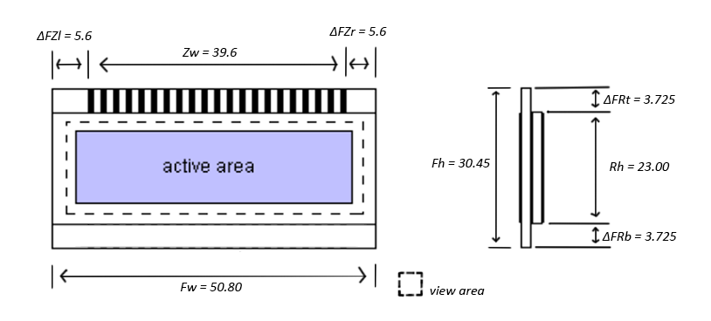
*View area： W 42.65 x H 18.15 mm *Glass thickness：
Active area：W x H mm 1.1 mm front
Front glass：W 50.80 x H 30.45 mm 1.1 mm rear
Rear glass：W 50.80 x H 23.00 mm

Critical dimensions:
- Front glass Width (Fw)
- Top of front glass(connector) - centered Zebra width(Zw) with equal edges on both sides

Other dimensions are not that important but still prefered to be as specified.

View Area Layout:
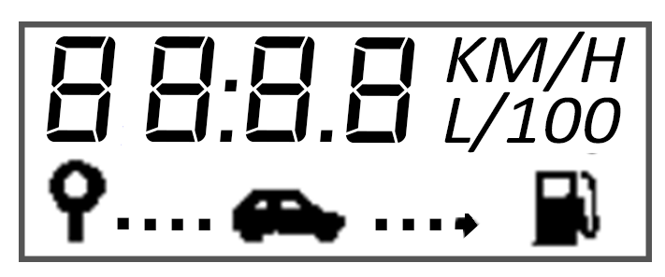

LCD Connection:
- Type: Elastomeric Zebra connector (already fabricated)
- 40 terminals (schema below)
- 38 segment
- 2 common (39 & 40)
- Terminal width: 0.6mm
- Gap between terminals: 0.4mm
- 40 terminals + 39 gaps between them: 40*0.6 + 39*0.4 = 39.6mm (Zw from first drawing)
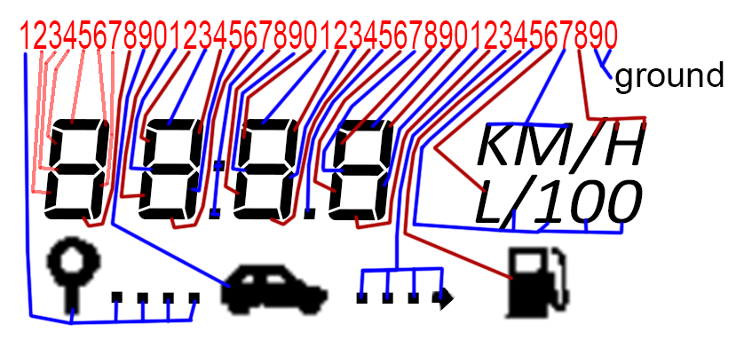

Polarizer:
- front: anti-UV, attached
- rear: attached
- reflective type

Display characteristics:
- Twisted Nematic (TN)
- Segment type
- Positive

View Angle
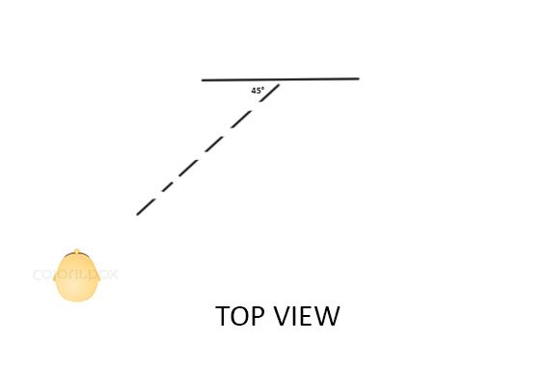

Temperature:

-10C ~ +50C

LCD Driver:

OKI Semiconductor MSM5219B
Datasheet attached

