Device Description

The device measures fuel consumption using a small turbine with IR emitter-detector pairs. The IR emitter is placed opposite to the IR phototransistor and the turbine between them. Each blade of the turbine passing interrupts the IR beam causing the phototransistor to modulate the signal. This signal is conditioned by an op-amp (Siemens TAA765A) and further processed by a digital flip-flop (MC14013BCP) to produce square wave impulses. Each impulse corresponds to 80 mm³ of fuel passing through.

Turbine

The turbine is installed in a 5.5 mm diameter bore and it has 3 blades.

Circuit
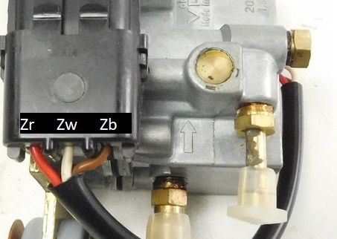
Zr- wire, battery+ (11-14V depending on battery/alternator)
Zw- wire, impulses output - one impulse per 80mm3 fuel flown
Zb- wire, battery-
A - 4.7nF capacitor, 100-160V
B - 10µF, 35V capacitor
C - Siemens TAA 765 A
D - 510K Ω
E - 3.6K Ω
F - 1K Ω
G - MC14013BCP
H1+H2 - IR phototransistor feed+ground
H3+H4 - IR emitter ground+feed, /1.4Vf/
I - 51K Ω
J - 51K Ω
K - 36K Ω
L - 150 Ω
M - zener diode (M1=Cathode, M2=Anode) 3.0-6.2V on different debitmeters
N - TFK L BD135 (N1=Base, N2=Collector, N3=Emitter)
O - 100 nF capacitor, 100V
P - 10K Ω
Q - 1K Ω
R - 10K Ω
S - BC237C (S1=Collector, S2=Base, S3=Emitter)
T - zener diode 6.2V (T1=Anode, T2=Cathode)
U - 510 Ω
V - 47 Ω (5 band, Gold)
W - diode, general-purpose rectifier (W1=Cathode, W2=Anode) 1N4006
X - 47µF 16V capacitor
Most common PCB revision D (as seen in top left corner):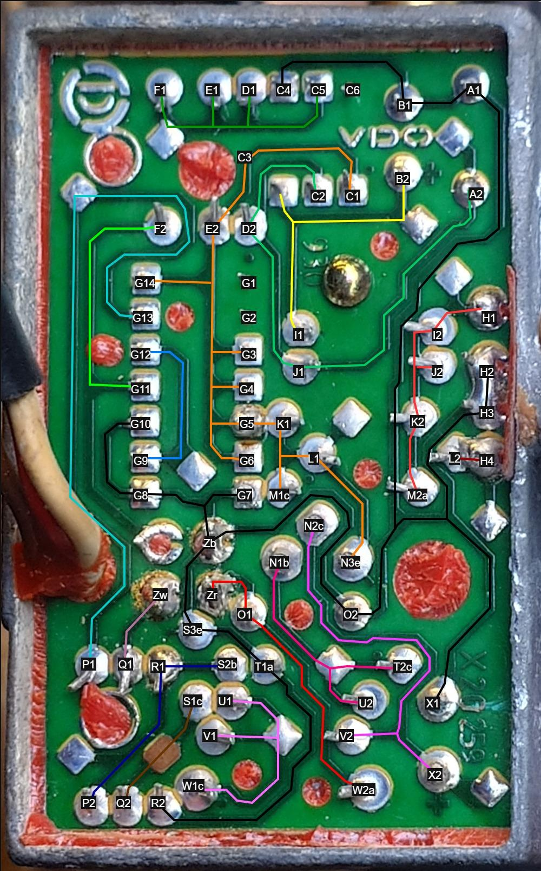
Revision E: small improvements with 2 more capacitors for filtering noise and accuracy improvement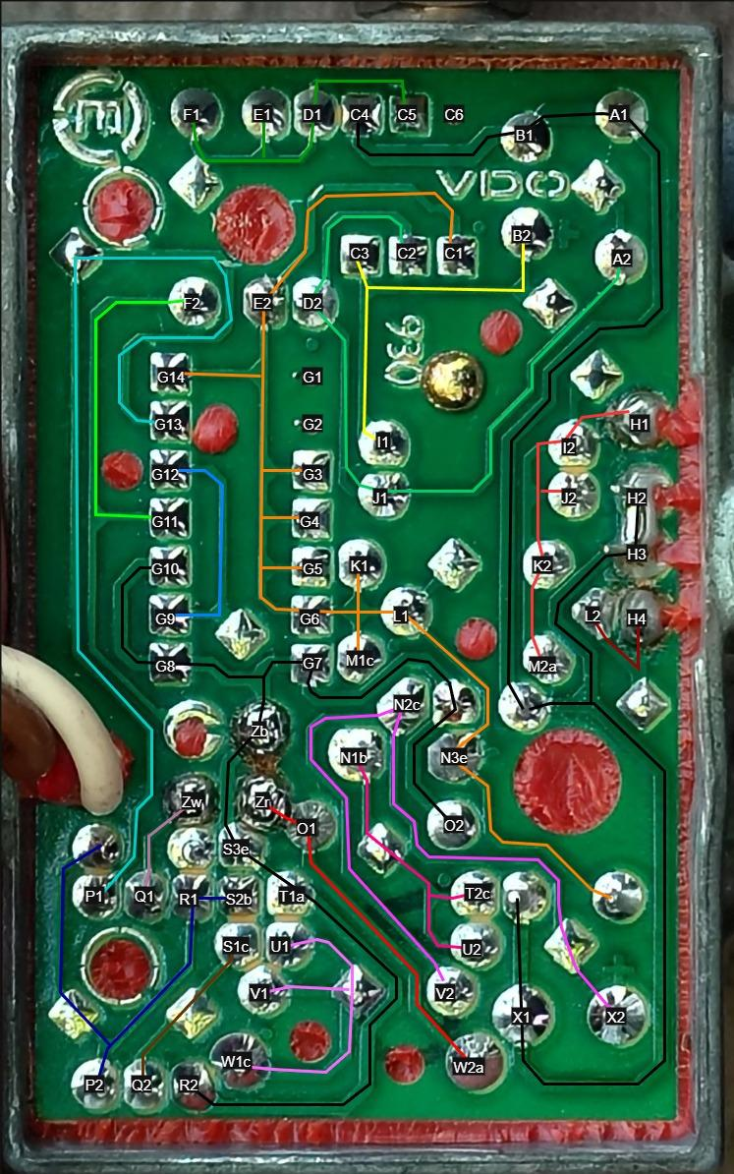

Relations

- 1 impulse = 80 mm³ (0.08 ml).
1 impulse = 1 square wave coming from component G
- 1 square wave from component G = 2 waves from component C
- 1 wave from component C = 1 turbine blade pass
- 1 turbine revolution = 3 turbine blades pass
=>
1 impulse = 2 turbine blades pass
1 turbine revolution = 120 mm³ fuel consumed
1 turbine blade pass = 40 mm³ fuel consumed
1mL fuel consumed ≈ 8.33turbine revolutions
1mL fuel consumed = 12.5 impulses
1L fuel consumed = 12,500 impulses

Experiments and signal behavior
Let’s have a look at two experiments:
- Manual rotation: 2 full revolutions in 1 second.
Spinning the turbine for 2 full revolutions in 1 second produces:
- 6 turbine blades passed
- Comparator C also outputs 6 cycles but cleans them into 12V-0V-12V-... instead.
- Digital Flip-flop G divides by 2 and reshapes these into 3 square pulses.
- At the output we see 3 clean square wave impulses. (3 impulses for 1 second = 3 Hz)
- Car driving: 50 km/h while consuming 4 l/100.
- litres per hour = L/h = (4/x=100/50) = (4/x=2) = 2 L/h
- mm³/s = 2 × 1,000,000 / 3600 ≈ 555.55 mm³/s
- output Hz ≈ 555.55 / 80 ≈ 7 Hz
- turbine revolutions/s ≈ 555.55 / 120 ≈ 4.63 revs/s
- turbine RPM ≈ 4.63 revs/s * 60s ≈ 278 RPM

Circuit Component-by-Component Analysis
Summary: The circuit is a turbine-type fuel flow sensor using an IR beam that is being interrupted by a 3-blade turbine.
IR led —-> - - - - - - - | - - - - - - - - ---> IR detector
(turbine blade)
An IR LED (H3–H4) emits an IR light and an IR phototransistor (H1–H2) is either illuminated or not, depending on the passing blades. The phototransistor changes its current(µA) according to its illumination. An op-amp (C) amplifies and thresholds these pulses to 12V/0V. A D flip-flop (G) toggles/divides the pulse stream, and an output transistor (S) produces the final pulse output (Zw). The circuit runs from the vehicle battery (Zr (+), Zb (–)) with local regulation and decoupling. Each component’s function, necessity, and interconnections are as follows:
- A – 4.7 nF capacitor: This small capacitor is connected to the op-amp's non-inverting input (In+). Because of its small value, it charges and discharges very quickly. This allows the In+ pin to react almost instantly to signals from the IR sensor, enabling fast voltage switching.
- B – 10 µF Capacitor: This much larger capacitor is connected to the op-amp's inverting input (In–). Its large size means it charges and discharges slowly, creating a stable, slow-moving voltage reference. The op-amp compares the fast-switching In+ against this steady In– to detect changes.
- C – Siemens TAA 765 A (Precision Op-Amp): This op-amp acts as a high-speed comparator. It constantly compares the fast-changing voltage from the sensor (at its In+ pin) with the stable reference voltage (at its In– pin). When the sensor sees an IR pulse, the op-amp's output snaps cleanly from high (5.5V) to low (0V), converting the analog sensor signal into a sharp digital pulse for the next stage.
- D – 510 kΩ resistor: This resistor sends a small piece of the output signal back to the input. This clever trick, called hysteresis, prevents the circuit from "chattering" or flickering when the IR signal is weak or noisy. It ensures a clean, decisive switch from on to off.
- E – 3.6 kΩ resistor: This acts as a pull-up resistor for the op-amp's output. It connects the output to the positive voltage, ensuring the signal is a clear "high" when the op-amp isn't actively pulling it "low." This guarantees a reliable signal for the next component.
- F – 1 kΩ resistor: This resistor sits between the op-amp and the flip-flop, acting as a protective buffer. It limits the current flow, preventing any sudden voltage spikes from damaging the sensitive flip-flop input, making the circuit more robust.
- G – MC14013BCP (Dual D-type Flip-Flop): This chip is configured as a toggle flip-flop, which functions as a divide-by-two counter. It receives pulses from the op-amp and changes its output state only on every second pulse. This clever setup ignores the duty cycle of the IR signal (how long the beam is blocked vs. unblocked) and produces a perfect 50/50 square wave output, ensuring consistent timing.
- H3–H4 – IR Emitter (LED): H4 is the IR LED’s positive feed; H3 is its ground. The LED is powered from the regulated 5.5V VDD (Path5) through the resistor L (150Ω), which is essential for limiting the current and preventing damage to the component.
The DMM Reading LED's forward voltage (1.4V): When testing the component with a multimeter's diode function, it passes a very small, brief test current. This gives the "cold" forward voltage before the LED has had a chance to heat up.
The In-Circuit Voltage (1.2V): When the circuit is powered on, a much larger, continuous current flows through the LED, causing it to reach its normal operating temperature. LEDs have a negative temperature coefficient, meaning their forward voltage decreases as they get hotter. The 1.2V measured is the true, stable forward voltage of the LED under its actual working load and temperature.
Therefore, the most accurate calculation for the circuit's operating current must use the in-circuit voltage of 1.2V:
I=RVDD​−Vf(operating)​​=150Ω5.5V−1.2V​=150Ω4.3V​≈28.7mA
This stable current of approximately 29mA is correctly set by the 150Ω resistor and provides a consistent IR beam for reliable operation.
- H1–H2 – IR Phototransistor (Detector): H1 is the phototransistor’s collector (feed), H2 is its emitter (ground). It faces the IR LED across the turbine slot. In operation, when IR light passes, the phototransistor conducts current from VDD (through K) to ground. Its collector voltage (node Path9) thus drops toward ground. In darkness (blade blocking IR), the phototransistor is off and Path9 is pulled up to VDD by resistor K. This creates a logic-level signal on Path9. The phototransistor replaces a mechanical switch – blades cause alternating light/no-light. The connections H1 (to Path9) and H2 (to ground Path1) implement a common-emitter circuit: collector to VDD through K, emitter at ground. This yields a digital-like output.
- I – 51 kΩ resistor: This resistor feeds the signal from the IR sensor to the op-amp's inverting (-) input. It works with resistor J to deliver the sensor's on/off signal to the op-amp so it can be processed.
- J – 51 kΩ resistor: Just like resistor I, this one feeds the IR sensor's signal to the op-amp's non-inverting (+) input. Using two identical resistors (I and J) creates a balanced network, helping the op-amp accurately detect changes from the sensor.
- K – 36 kΩ resistor: This is the load resistor for the IR phototransistor. When no IR light is detected, this resistor pulls the signal voltage "high." When light hits the sensor, the sensor pulls the voltage "low." This resistor is essential for converting the detection of light into a clean, usable electrical signal.
- L – 150 Ω resistor: This resistor's critical job is to limit the current flowing to the IR LED. Without it, the LED would draw too much power and burn out instantly. Its value is chosen to make the IR beam bright enough for reliable detection without damaging the component.
- M – zener diode: This diode serves as an input protection device. It's connected to the phototransistor's output line to clamp any potential voltage spikes, preventing them from exceeding the circuit's supply voltage and damaging other components.
- N (BD135, NPN transistor): This is the workhorse of the power supply, acting as a pass transistor in a simple voltage regulator. It takes the fluctuating 12-14V input from the vehicle's battery and, controlled by the Zener diode (T), outputs a steady, lower voltage (~5.5V) to power the rest of the circuit.
- O – 100 nF Capacitor: This is a decoupling capacitor placed right at the raw battery input. Its job is to filter out high-frequency electrical noise and voltage spikes from the vehicle's alternator or ignition system, protecting the sensitive electronics from "dirty" power.
- P – 10 kΩ resistor: When the logic circuit decides to send a pulse, this resistor delivers the "turn-on" signal to the final output transistor (S). It limits the current to a safe level, ensuring the transistor switches on properly without being damaged.
- Q – 1 kΩ resistor: This resistor is located on the final output wire (Zw) as a safety feature. It limits the current of the outgoing pulse, protecting the output transistor from potential short circuits or damage from the Trip Computer.
- R – 10 kΩ resistor: This is a pulldown resistor. It connects the output transistor's "on" switch (the base) to the ground. This guarantees the transistor stays firmly off when it's not supposed to be active, preventing false output pulses caused by electrical noise.
- S – BC237C NPN transistor: This transistor is the final output driver. It takes the low-power logic signal from the flip-flop (G) and converts it into a more robust signal capable of driving an external device. When it receives a "high" signal, it turns on and pulls the output wire (Zw) to ground, creating the final active-low pulse.
- T – 6.2 V Zener diode (BZX55C_6V2): This Zener diode is the heart of the voltage regulator. It creates a stable 6.2V voltage reference. The regulator circuit uses this precise reference to control the pass transistor (N), ensuring the final output voltage remains constant even if the battery voltage fluctuates.
- U – 510 Ω resistor: As part of the power regulation circuit, this resistor supplies the "turn-on" current to the main power transistor (N). This allows the transistor to properly regulate and stabilize the voltage that powers the entire device.
- V – 47 Ω resistor: Also in the power regulation circuit, this resistor helps smooth the power delivery under changing loads. It shares some of the heat and workload with the main power transistor (N), improving the overall stability and reliability of the circuit's power supply.
- W – 1N4006 silicon diode: This diode sits at the main power input and serves two purposes. First, it provides reverse polarity protection, acting like a one-way valve to prevent damage if the battery is connected backward. Second, it creates a small, fixed voltage drop as part of the regulation scheme.
- X – 47 µF, 16 V electrolytic capacitor: This is a bulk filtering capacitor for the circuit's internal regulated power supply. It acts like a small, local power reservoir, smoothing out the voltage and providing extra current during brief, high-demand events, ensuring the circuit has a stable and clean power source.
- Zb (Battery –): This is the ground reference for the entire circuit.
- Zr (Battery +): The main positive power input for the circuit. It connects to the vehicle's battery or alternator and supplies the raw, unregulated 11-14V.
- Zw (Impulse Output): This is the final signal output wire. The circuit sends a ground signal on this wire for every measured unit of fuel. It's an "open-collector" output, meaning it's designed to be connected to an external computer or gauge that will read these pulses.
Summary of component roles: In essence, the resistors and capacitors set the analog timing and thresholds of the IR sensor amplifier (A, B, D, E, I, J, K, M), the op-amp (C) creates a clean pulse, the flip-flop (G) toggles those pulses, and the transistor (S) drives the output (Zw). The diodes and transistors in the supply path (N, W, T, U, V, X) regulate and decouple the power rails, while decoupling caps (O, X) filter noise. Each value is chosen for a balance of sensitivity, speed, and safety. Smaller or larger values would shift thresholds, slow the response, or overload parts. The use of an MC14013 flip-flop (with D tied to /Q) is exactly “for counter and toggle applications” as noted in its datasheet. The overall design thus implements a reliable real-world fuel flow measurement (in place of any simulation) by carefully selecting each component’s role and connections.

Zw should switch to ground with every impulse, so why doesn't it show 12V the rest of the time?
Zw is an open-collector output driven by transistor S (BC237C). An open-collector stage cannot generate voltage on its own; it only sinks current to ground. Without a pull-up resistor, Zw simply floats when the transistor is off, so a multimeter sees no defined voltage. When the transistor turns on, Zw is pulled close to 0V.
Adding a 10 kΩ pull-up resistor between Zw and +12 V fixes this: when the transistor is off, battery power comes through the resistor pulling it up to 12V. When the transistor switches on, it sinks about 1.2 mA through the pull-up and forces Zw low. Thus, Zw becomes a clean digital signal: 12 V idle, 0 V pulses.

The onboard computer does exactly this but instead with 5V!

Troubleshooting

Disclaimer.
The instructions and information contained in this guide are provided “as-is” for informational purposes only. The author (the “Author”) is not a professional safety advisor and expressly disclaims any warranty, express or implied, as to the accuracy, completeness or safety of the procedures described. By using this guide — including, without limitation, cutting polyurethane (PU) resin with a hobby knife, working with fuels and solvents, and handling 12-volt batteries and multimeters — the reader assumes all risk of injury, property damage or other loss. Neither the Author nor any affiliates, contributors or publishers shall be liable for any direct, indirect, incidental, consequential, special or punitive damages, including personal injury or death, arising out of or in connection with the use of, or reliance upon, this guide. Users must take appropriate precautions, follow applicable laws and regulations, use proper protective equipment, and seek qualified professional advice or training where necessary.
If the car is running and fuel is flowing but the ODB doesn't get any consumption reading, many failure modes must be considered.
Most of the time the main culprit is car vibration which breaks the solder joints but other faults can be also present.
We break these into physical/mechanical, power input and internal circuit issues. We also discuss four diagnostic approaches (in-car test, bench test, partial and full removal of the resin) with step-by-step suggestions. Throughout, keep safety in mind: resin removal is hazardous (wear gloves, goggles, ventilate, see below), and any fuel connections or engine wiring must be handled properly.

Issues

A) Physical (Mechanical/Fluidic) Issues
- Turbine not spinning (no flow or jam). If the turbine impeller is not turning, no pulses will be generated. Common causes are debris or sludge in the fuel (rust, scale, sealant, algae, etc.) or air pockets(unlikely).
- Turbine damage or wear. A broken or bent turbine can cause erratic output or no output even with good fuel flow.
- Fluid opacity or contamination. Even if the rotor spins, cloudy or dirty fuel can block the IR beam between the emitter and phototransistor. Turbine meters with IR pickups often fail when the fluid is opaque.

B) Electrical / Circuit Issues
- Power-supply wiring. The device should be powered with 11–14 V (~14V with engine running and alternator charging). Intermittent/missing power will cause no pulses.
- Ground problems. Ground wire of the debitmeter goes through the onboard computer. This is a terrible design by Renault. Not only it has a long distance but a lot of connectors to travel through. It's a better idea to re-route it and make it solidly grounded. A bad ground (high resistance) can leave the circuit starved for current.
- Internal circuit failure.
a) though the circuit is in resin and anti-vibration dampers are placed on the mounting bolts, extreme vibration or thermal cycling can crack solder joints.
b) most of the internal components are critical to the operation of the device, one failing component will render the whole device non-operational.

Diagnostics and repair methods

A) In-Car Testing
With only the three wires accessible, basic troubleshooting can be made:
- Measure power supply:
needed: multimeter
disconnect the debitmeter and measure the voltage coming from the car to the red and brown wires. It should be around 11–14 V with the engine running. If there is no or low voltage, the fault is upstream: check fuses, wiring, connector pinout, and alternator output. Repair any poor connections or open circuits on Zr/Zb. An intermittent power lead can cause no pulses.
When you check (and fix if needed) the car wiring, proceed to A2.
- Measure power consumption:
needed: multimeter
After proving power is getting to the connector, let’s test if the debitmeter is using any power and showing any signs of life. Connect the multimeter in series between debitmeter and battery + terminal:
multimeter red wire<>debitmeter red wire
multimeter black wire<->car battery +).
connect the debitmeter brown wire to battery-/ground.
A functioning device uses about ~40mA. If it’s much lower or even none, something is wrong (component, path, solder or your multimeter).

B) Bench Testing (Debitmeter out of the car)
Blowing into the debitmeter:
- Buy a new clean hose to not get fuel fumes in your mouth when blowing. For some tests you can use an aquarium air pump.
- Do not use compressed air. The turbine inside rotates with 4000RPM short burst when the carburetor is empty and about 2500RPM maximum when the engine is at full throttle and high RPM, compressed air might overexceed that and break it.
- Test turbine spinning:
Place the debitmeter near your ear and use the hose to blow into the "→" inlet of the debitmeter. You should hear a very quiet but distinct turbine sound "dzzzzzz". If you don't hear it try to vary the force you are blowing with but you don't need to force your lungs out. If it works it works. If not - it needs unblocking.
Unblocking: First remove the 4 screws and with light lateral taps with a hammer remove the upper cover and membrane.
Check the condition - if there is a lot of white powder or scale - the turbine is also blocked with that.
To dissolve that: I use Citric acid:water and mix it in 1:4 ratio (20-80).
1. Dunk both halves of the debitmeter and the membrane into the solution. It will start to bubble.
wait 10-13 mins.
2. Stop the reaction from happening - flush thoroughly with water making sure you get all of the solution from the internal passages. (very important, otherwise the acid will start attacking the aluminum body)
3. Spray everything with carburettor cleaner, especially in the hole in the chamber and let it sit for 5 mins
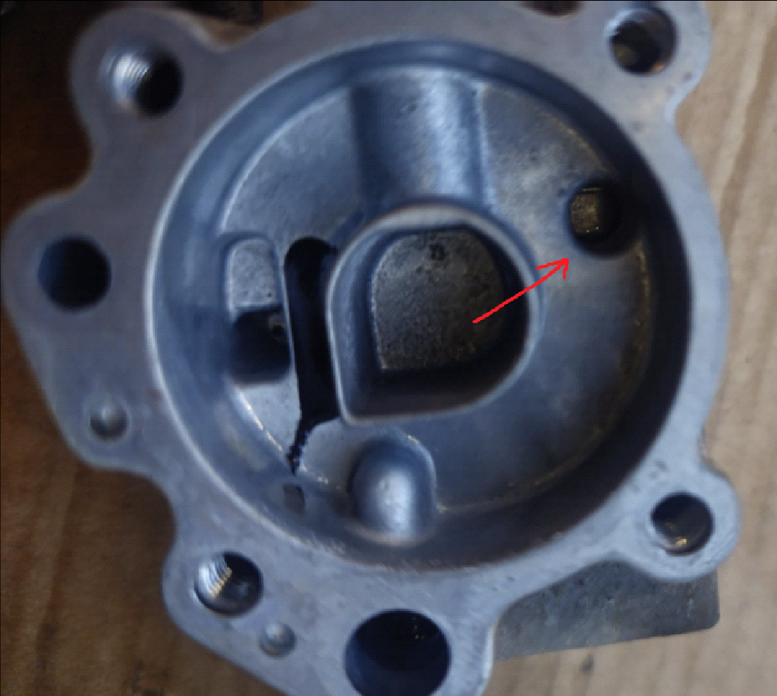
4. Repeat 1-2-3 until white junk is removed and the debitmeter looks like on the picture (clean, no white varnish/gunk)
5. Test again when the debitmeter is clean like on the picture. Close the debitmeter(otherwise the air will escape from multiple passages) - put everything together - the membrane, the main body, upper half and the metal bracket, screw at least 2 diagonal bolts. Blow into it and test if you can hear the turbine spinning
if you can hear it - spray WD40/silicone lubricant inside the passages to displace any water, lubricate the turbine and prevent it from seizing
if you can't hear the turbine - it's either hard blocked or broken(very unlikely), as a last resort you can pull out the brass plug near the excess fuel outlet and try to poke the turbine to see if it rotates. The turbine is located between two "+" shaped aluminum objects that hold it in place and is very difficult to reach.
- Measure impulses: If the power usage was ~40mA, if it was lower - something is not functioning as it should
needed: 12V battery, multimeter, 10k Ω resistor
Be very careful not to short something, it can be catastrophic.
Connect
- Zr -> Bat+
- Zw -> 10kΩ -> Bat+
- Zb -> Bat-
- multimeter to Zr and Zw:
A) multimeter has Hz measurement mode?
blow into the "→" inlet of the debitmeter:
Hz>0 debitmeter is operational, connect to the car and trace the problems elsewhere
Hz=0 debitmeter not operational
B) multimeter Voltage measurement mode(DC not AC!)
blow into the "→" inlet of the debitmeter and watch the reading:
stuck on battery voltage/0V problem in the circuit
≈battery voltage/2 debitmeter is operational, connect to the car and trace the problems elsewhere
Explanation: When you connect Zr and Zb to the battery, you power up the components inside.
Zw is the output wire. It should pulse to ground(0V) each time the turbine spins. If you connect Zw to a large resistor (like 10 kΩ) you give it a very weak 12 V, the components inside are strong enough to override the weak 12V and pulse to ground. So it should start moving 0V-12V-0V-12V (battery voltage/2) which the multimeter will sense
If Zw stays stuck at 0 V (ground) or 12 V (power), the parts inside don’t work properly.

C) Partial resin removal (Access to PCB Traces)
If on-bench tests still show no pulses and you consider yourself brave and an electrician let's proceed to carefully removing resin only on the PCB top side (where traces are) to access test points. This is delicate and should in no circumstances be rushed or you're risking damage to the circuit.
This guide is only providing information on how to start, you need to have a deep electronics understanding so you can troubleshoot which part of the circuit is broken.
Tools: I use a sharp hobby knife, soldering station, 12V battery, multimeter
- Make 2-3mm deep cuts where the resin meets the aluminum edges. Careful to not cut yourself or the 3 cables or very deep into the resin. You only need to separate the resin from the aluminum
- Use something to start pushing and peeling off the resin. You will need to balance the force so you actually do something but not that hard that you damage the circuit. Patience is key.
You can also try a heat gun to soften the resin but be very careful not to exceed far above 100°C and damage the circuit.
- When you remove the resin you can start inspecting the components - check for obvious dark spots on the circuit or solder joints cracked/darkened.
- You can start probing with a multimeter to see different components, you can also power the device using a 12V battery connected to Zr and Zb and check for 12V for the different circuit paths - most importantly, from the schematic above, the orange path coming from N3e component.
- If you need to solder something - use
62Sn/36Pb/2Ag, Sn63/Pb37 or Sn60/Pb40 solders
(Lead-free /no Pb/ solders are stiffer and more brittle. In a vibration environment, microcracks can propagate much faster.)
use quality flux and aim to create well-shaped concave solders (volcano shaped).
Example of broken solder joints:
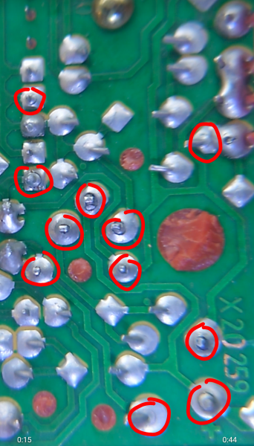
Some joints may appear good but they still can be damaged, probe with a multimeter and to have a peace of mind - redo ALL the solder joints. Even if only one is cracked others will soon follow.

D) Full Depotting (Complete Resin Removal)
If all the joints were repaired but the circuit still fails and some components need to be replaced, you need to remove the board from the resin entirely. This is extremely challenging, tedious and time consuming.
A bit more info on circuit "potting" in resin: https://www.pottingcompound.com/how-to-remove-potting-material-from-a-pc-board/#:~:text=1,damaging%20the%20PCB%20or%20components
typical solvents:
MEK (Methyl Ethyl Ketone): Fast-evaporating, strong solvency for vinyl, acrylics, and lacquers; component in paint removers and dry cleaning fluids; used to clean uncured and cured resins and coatings
Acetone: Highly volatile, fast-evaporating, strong cleaner for stripping and cleaning resins and coatings, and for equipment cleaning
Xylene/Xylol: Moderate evaporation rate, excellent solvency, and helps dissolving various resins, lacquers, and paints; can be used to thin epoxy and other adhesives.

1.
- You need to remove the top resin first
- unsolder the 4 IR legs /H1,H2,H3,H4/
- The wanted result is to pull out the whole resin block with the circuit embedded in it and only the 4 IR sensors legs should be left:
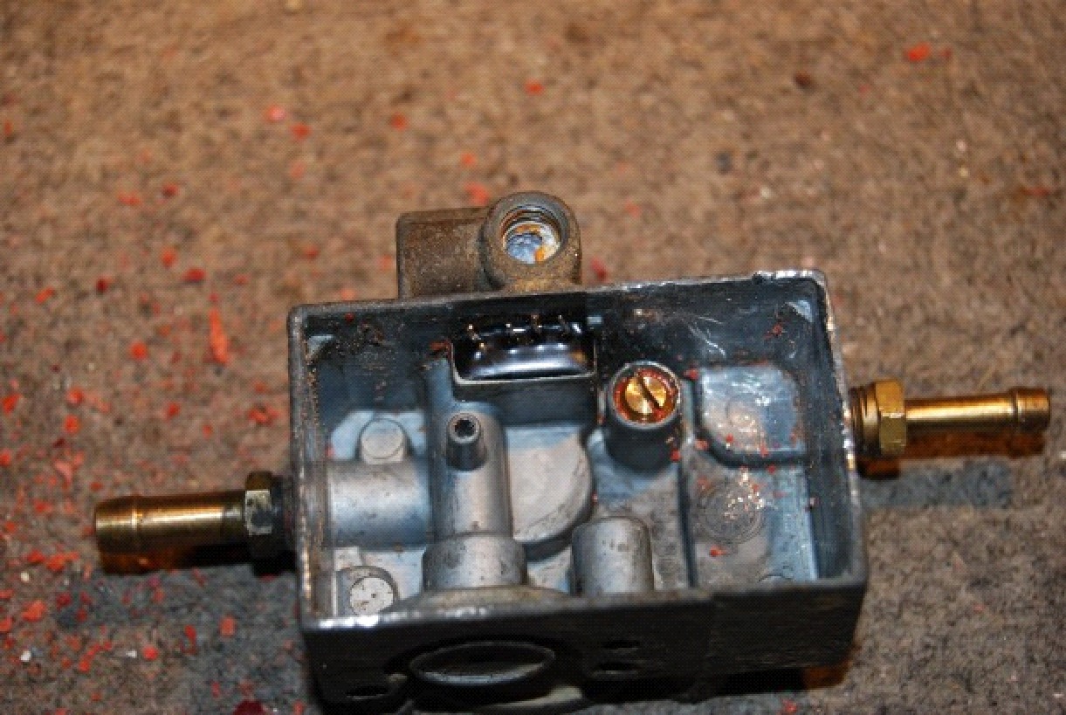
2. Polyurethane potting is tough. Use any combination of methods that you are comfortable with:
- Heat: Apply a gentle heat gun or controlled oven (e.g. 80–100 °C) to the resin – this can make it softer and less glassy. Be cautious not to exceed ~100 °C for long, to avoid damaging PCB or metal parts.
- Chemical soak (optional):
Prolonged immersion in acetone or MEK can gradually soften polyurethane, xylene/xylol can make it brittle. According to guides, soaking small areas and reapplying solvent repeatedly can weaken the resin bind (but it is slow and toxic). For example, drape acetone-soaked cloth over the board under plastic wrap for hours, then scrape away softened bits. Warning: Acetone can attack some plastics and the PCB substrate. Test on a scrap first if available.
- Mechanical removal: Once heated or soaked, use precision tools to carefully separate the bond between the aluminum casing and the resin.
- The even more difficult part is actually separating the resin block from the components. The resin is not only on top but also between the components and PCB board.
You can unsolder everything and separate only the PCB.
Then either find replacement components or try to remove them from the resin.
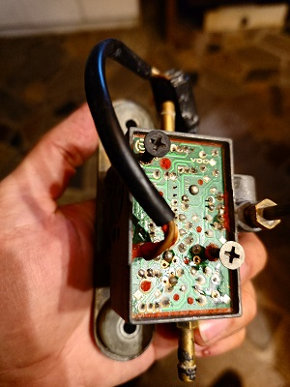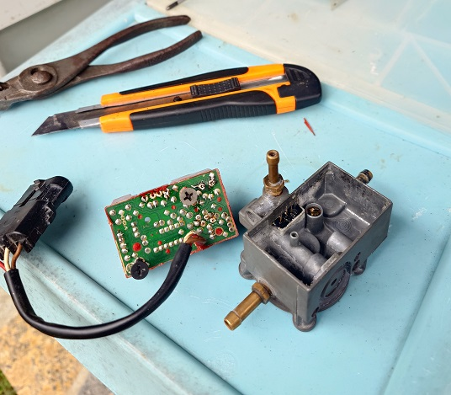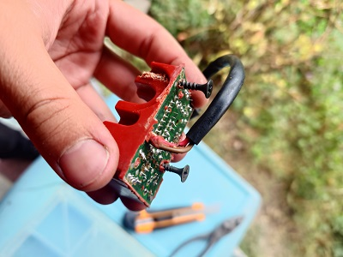

After repair
- you need to re-pot the board for protection - from vibration, moisture, high temperature, gasoline/oils.
- The original VDO red potting compound is polyurethane with oil/fuel resistant properties.
- You can use silicone/polyurethane electronics-grade potting compounds. (e.g. Electrolube).
- Fuel resistant compounds are generally harder and don’t dissipate vibrations but you don’t need to worry about fuel/oil spills, on the other hand - you can use a softer compound that is not chemically resistant if you are sure you will clean any leaks on the debitmeter within a few hours.
- I personally use neutral silicone for bathroom mirrors (very important to be neutral, acetic silicones that smell sour when curing are damaging the circuit)
but silicone is very gummy and difficult to remove once it’s cured and it’s not fuel resistant.
- There is no perfect seal for this device - combination of vibration, moisture, high temperature, gasoline/oils is very difficult to overcome and there are trade-offs with each choice

